1. SNL VS Indigenous Land

Overlapping percentage between PRIO GRID cell including SNL property and PRIO GRID cell including Indigenous Land: 42.10%

* Red spots: Point location of SNL mining properties
* Blue cell: PRIO GRID cell with Indigenous Land

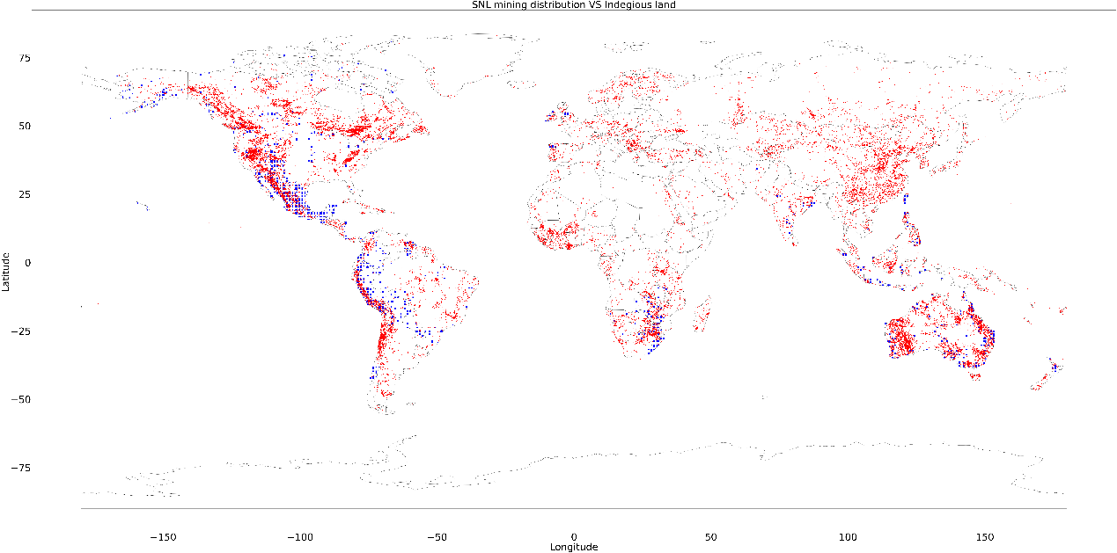

1. WHC VS Indigenous Land

Overlapping percentage: 2.07%

* Red spots: Point location of World Heritage Project
* Blue cell: PRIO GRID cell with Indigenous Land

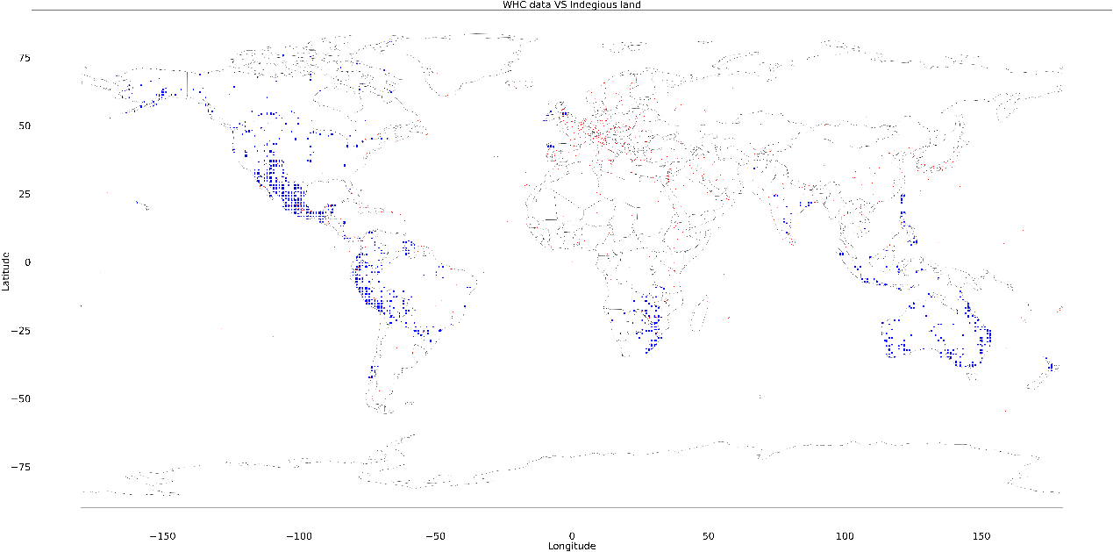

1. GISProject VS Indigenous Land

Overlapping percentage: 1.84%

* Red spots: Point Location of World Bank Projects
* Blue cell: PRIO GRID cell with Indigenous Land

